**Issue 10**“Use as my default payment” is not present in the card input fields

**Description** It would be good if we can give a checkbox “Use as my default payment” in the payment screen; so that the returning user doesn’t need to provide the card details again. 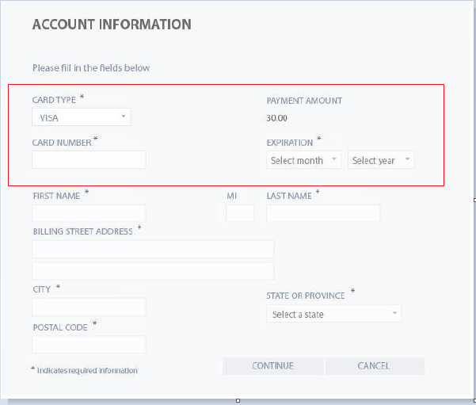

**Expected Behavior**: “Make this default payment” checkbox should be present

**Severity**: Minor